Chair of Pico and Nano Satellites, and Satellite Constellations TUM School of Engineering and Design Technical University of Munich


Spacecraft Design – Project Description

The Spacecraft Design project requires students to examine a mission statement and a description of the mission, and then detail and size the spacecraft subsystems and produce an overall spacecraft design. The students are divided in groups of 6-8 members.

Topics – Mission Statement


Finding Plastic Patches in the Pacific Ocean using Optical Satellite Observations

“At Ocean Voyages Institute, we recognize the urgent need to address the growing issue of plastic pollution in our oceans. Our mission is to develop a spacecraft capable of gathering accurate and comprehensive data on plastic concentration in the Pacific Ocean, particularly in identifying plastic clusters.

We envision a spacecraft equipped with optical instrumentation that can track and map plastic debris, providing us with vital information on the location, and size. With this data, we can gain a deeper understanding of the scale of the problem and develop effective strategies to mitigate its impact.

Our goal is to create a spacecraft that can operate with precision and efficiency, covering large areas of the Pacific Ocean to gather the most comprehensive data possible. We believe that this mission will play a critical role in raising awareness of the plastic pollution crisis and catalyzing action to address it.

Through our work, we hope to inspire others to join us in the fight against plastic pollution and to create a cleaner, healthier ocean for generations to come.”
April 14, 2023

Parameters

Orbit

- Initial orbital parameters:

Parameter | Values
Semimajor axis (a) | 6371 + 250 + 10*(Num.Group -1) [km]
Eccentricity (e) | 0
Inclination (i) | 0
RAAN (Ω) | 0
True anomaly ( ) | 0
Argument of Perigee ( ) | 0

Resolution
Ground Sampling Distance (GSD) = 20 + 8 ∗ ( . − 1) [m]
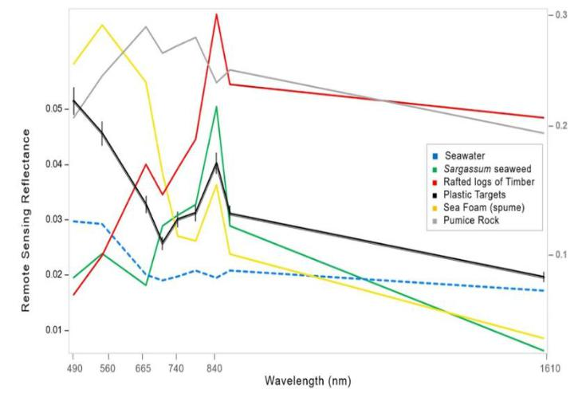

Wavelength selection¹

- NIR wave (λ = 880nm): To distinguish plastic from water.

- Blue light (λ = 443nm): To distinguish plastic from:

  - seaweeds
  - timber
  - other debris

Figure 1- Remote Sensing Reflectance of sea floating materials

Temperature Range: -30 degrees Celsius to 60 degrees Celsius TT&C system
- Losses of the receiving antenna: 3 dB

- Biermann, L., Clewley, D., Martinez-Vicente, V. et al. Finding Plastic Patches in Coastal Waters using Optical Satellite Data. Sci Rep 10, 5364 (2020). https://doi.org/10.1038/s41598-020-62298-z

2
April 14, 2023

- Antenna perfectly aligned and there are no polarization mismatch losses

- Satellite is on the zenith of the ground station and there are no obstacles or atmospheric losses

N.B. You have to design a single spacecraft and not more than one. No constellations or swarms.

What to include in the report – Everything must be justified

- Mission objectives: primary objective, secondary objectives

- Main requirements

- Technical requirements for each subsystem

- System Architecture

- System
  - Mass Budget

  - Power Budget

  - Link Budget

- Mission Orbit & DeltaV
  - Orbital parameters of the target orbit

  - Ground track of the target orbit

  - Sun light and eclipse time

  - DeltaV to reach the target orbit

  - Deorbit manoeuvre

- Propulsion system
  - Type of propulsion system selected with main parameters (Isp, T)

  - Propellant mass

- Launcher selection

- Ground Segment:
- Ground station location selection

- Spacecraft
  - Payload: Optical instrumentation sizing (diameter and focal length)

3
April 14, 2023

- AOCS

  - Sensors and actuators

- Power Subsystem

  - Solar Arrays Size and Mass

  - Battery Size and Mass

- TT&C subsystem

  - Frequency band selection

  - Antenna selection

- Structure

  - Size of the satellite

  - Material definition

  - Configuration/placement of the subsystems

- Thermal subsystem

  - Hot and cold case temperature

  - Coating and passive and/or active thermal control instruments

Info about the report and the presentation

The examination consists of a report accompanied by a final presentation. Grading is based on the submitted report, and a final presentation at the end of the semester serves as a grade modifier.

- The presentation has to have a duration of 10 minutes (all the members of the group have to present), followed by a Q&A session.

- The report length has to be limited to 15 pages. Each student has to specify the personal contribution at the beginning of each paragraph.

- The presentation will occur the last day of lecture, on the 20th of July 2023.

- The report has to be delivered within the 30th of July 2023.

4

